CO5 ASSESSMENT TOOL-2

Q89. Maximum Cut Approximation by Sequential Assignment
Aim
To develop an approximation algorithm for the Maximum Cut Problem by sequentially assigning vertices to one of two partitions such that each vertex contributes the maximum possible number of crossing edges.
Input
- Graph $G=(V,E)$
  - $V$= Set of vertices
  - $E$= Set of edges
Example:
V = {A, B, C, D}
E = {(A,B), (A,C), (B,D), (C,D)}
Output
Two partitions:
P1, P2
representing an approximate maximum cut.
Example:
P1 = {A, D}
P2 = {B, C}
Algorithm Idea
Process vertices one by one.
For each vertex:
- Count how many edges would cross the cut if the vertex is placed in P1.
- Count how many edges would cross the cut if the vertex is placed in P2.
- Place the vertex in the partition that creates more crossing edges.
- Continue until all vertices are assigned.

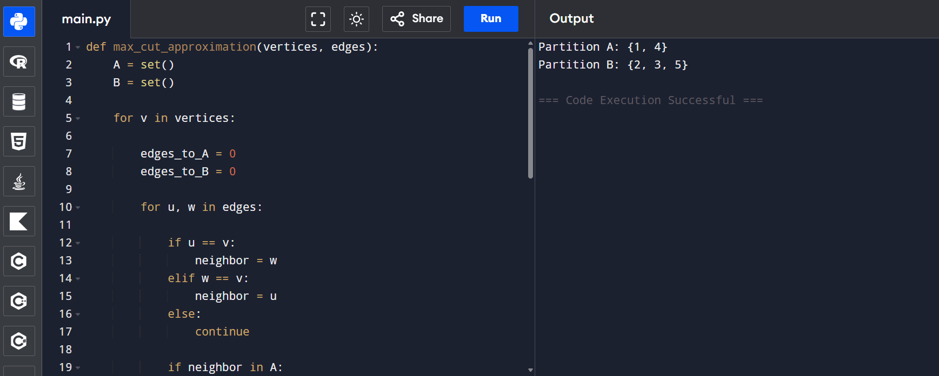
Q53. Subset Sum with Negative Numbers
Aim
To develop a Backtracking algorithm that finds all subsets whose sum equals a given target value when the set may contain both positive and negative numbers.
Input
- Set S = {s₁, s₂, s₃, ..., sₙ}
- Target Sum T
Example:
S = {3, -2, 5, -1, 4}
T = 5

Output
All subsets whose sum equals the target.
Example:
{5}
{3, -2, 4}
Algorithm
Step 1
Start from the first element of the set.
Step 2
For each element:
- Include it in the current subset.
- Exclude it from the current subset.
Step 3
Update the current sum after inclusion.
Step 4
Use recursion to explore both possibilities.
Step 5
If all elements are processed:
- Check whether current sum equals target.
- If yes, print the subset.
Step 6
Apply pruning using possible minimum and maximum remaining sums.
Step 7
Continue until all combinations are explored.
Output
Valid Subsets:
{5}
{3, -2, 5, -1}
Time Complexity
Worst Case: O(2^N)
(All subsets may need exploration.)
Space Complexity
O(N)
(Recursion stack and subset storage.)

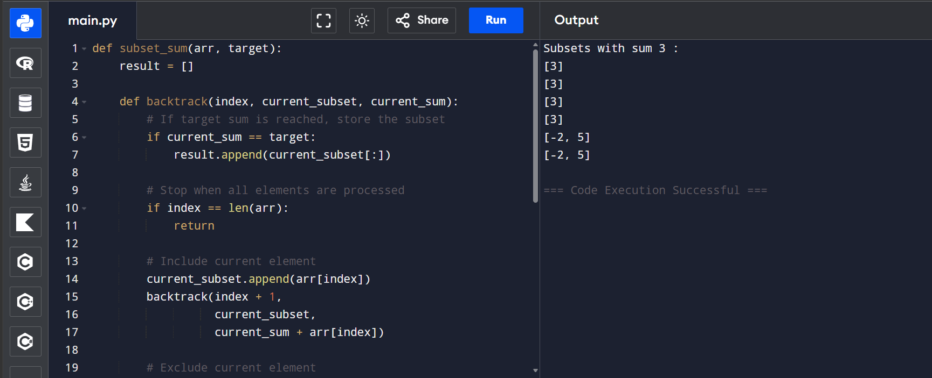
Q65. Approximation Vertex Cover Problem
Aim
To develop a 2-Approximation Algorithm for the Vertex Cover Problem that selects vertices to cover all edges in a graph and produces a solution whose size is at most twice the optimal vertex cover.
Input
- Graph $G=(V,E)$
  - $V$= Set of vertices
  - $E$= Set of edges
Example:
V = {A, B, C, D}
E = {(A,B), (A,C), (B,D), (C,D)}
Output
A vertex cover set $C$such that every edge has at least one endpoint in $C$.
Example:
Vertex Cover = {A, B, C, D}
Algorithm
Step 1
Initialize an empty vertex cover set $C$.
Step 2
While uncovered edges exist:
- Select any uncovered edge (u,v).
- Add both endpoints u and v to C.
- Remove all edges incident on u or v.
Step 3
Repeat until no edges remain.
Step 4
Return C as the approximate vertex cover.

